**First Demo**

**Finder Matchmaking Web Application**

**Team members:**

**Trần Thái Dương**

**Đỗ Đức Cường**

**Hoàng Hữu Phước**

**Nguyễn Thành Huy**

**Đỗ Đình Dũng**

# Introduction

## Purpose

This documentation plays a vital role in introducing and conveying project ideas effectively. It enables readers to visualize the software's objectives, key features, and functionality through illustrative screenshots or video demonstrations. Additionally, this documentation serves as evidence of development progress, showcasing what has been accomplished and the current stage of the project.Furthermore, presenting demo documentation provides an opportunity to gather feedback and suggestions from professors, peers, or potential users. This feedback loop helps identify potential issues and explore solutions for software improvement. Ultimately, the documentation acts as a valuable reference for developing advanced features and supporting efficient project planning and management in subsequent stages.

## Scope

This software system, Matchmaking Website, will be used by the public as a medium for socialization. The software will be designed to let users search and join small group activities based on their preference.More specifically, the system is designed to let users find a group of people to do an activity with via the Internet. The system allows users to either host or join an activity session. Users who host activity sessions can set up a schedule with location and activity. Meanchile, users who seek to join an activity session can search for activities or have the activities recommended to them based on location and matching schedules.

## References

IEEE. IEEE Std 830-1998 IEEE Recommended Practice for Software Requirements Specifications. IEEE Computer Society, 1998.

## Overview

This document delves into the core of Finder, starting with a brief overview of its goals and target audience. It then visually explores key features through screenshots and/or video demonstrations, followed by explanations of their functionalities and workflows. Finally, we address development challenges and propose potential solutions for improvement.

# Overall Introduction

Finder is your go-to platform for creating and discovering exciting offline events. Connect with like-minded individuals, join local happenings, and build lasting memories together. With our intuitive event creation tools, planning your next gathering is a breeze. Share details, engage in discussions, and foster a sense of community through our interactive event comment sections. Finder– where connections spark and experiences come alive.

# Functionality Showcase

## 3.1. Login

## 3.2. Sign up

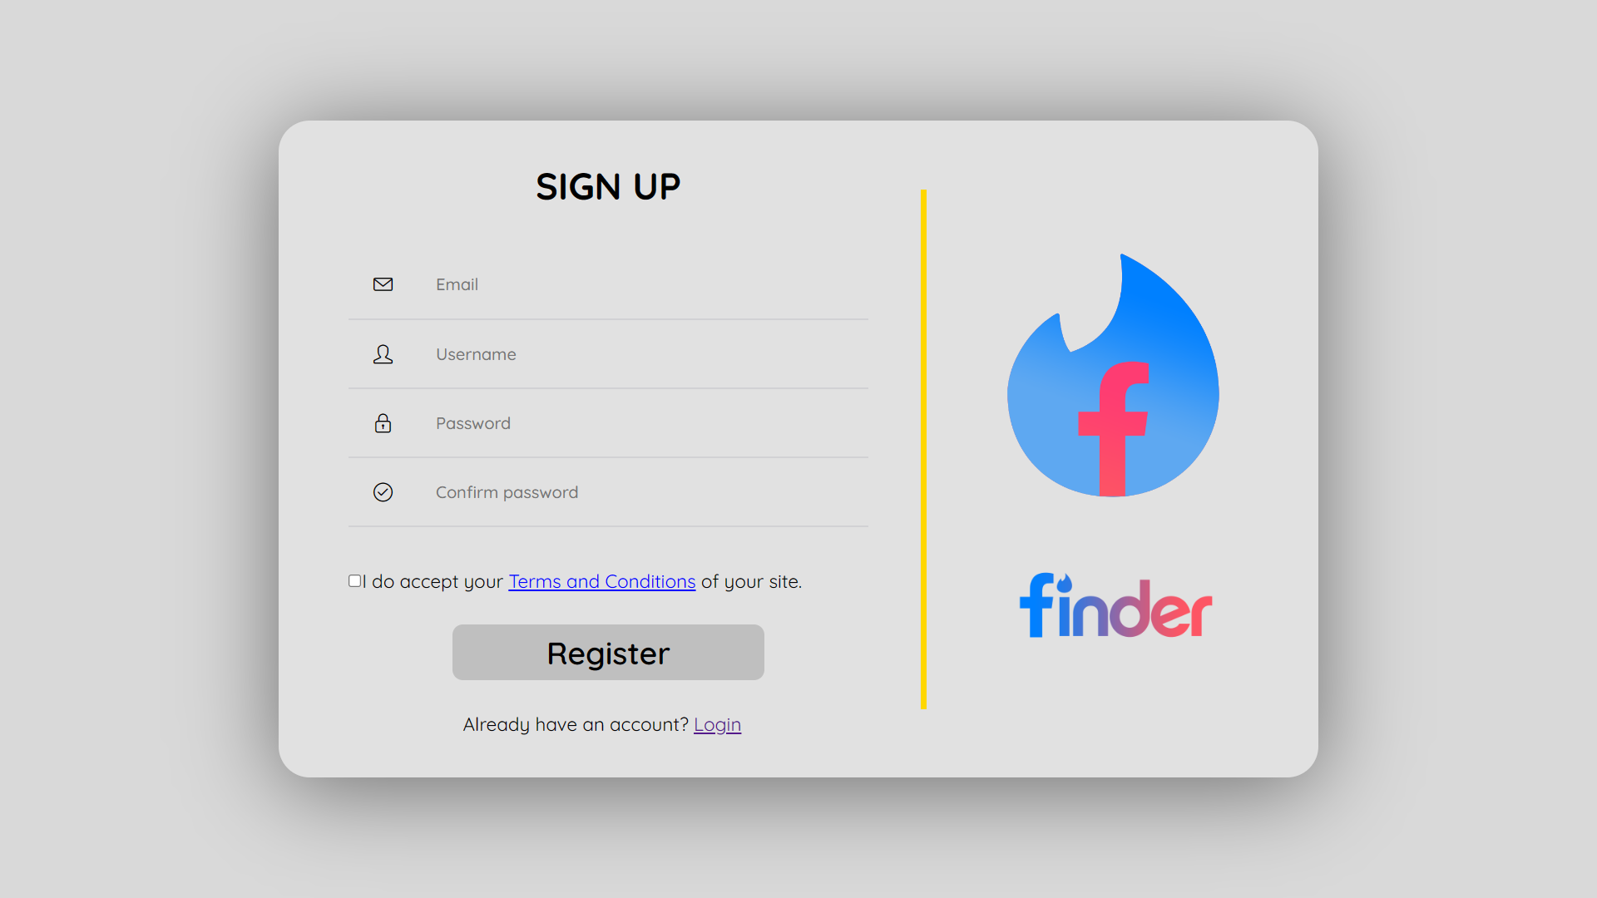

## 3.3. Home

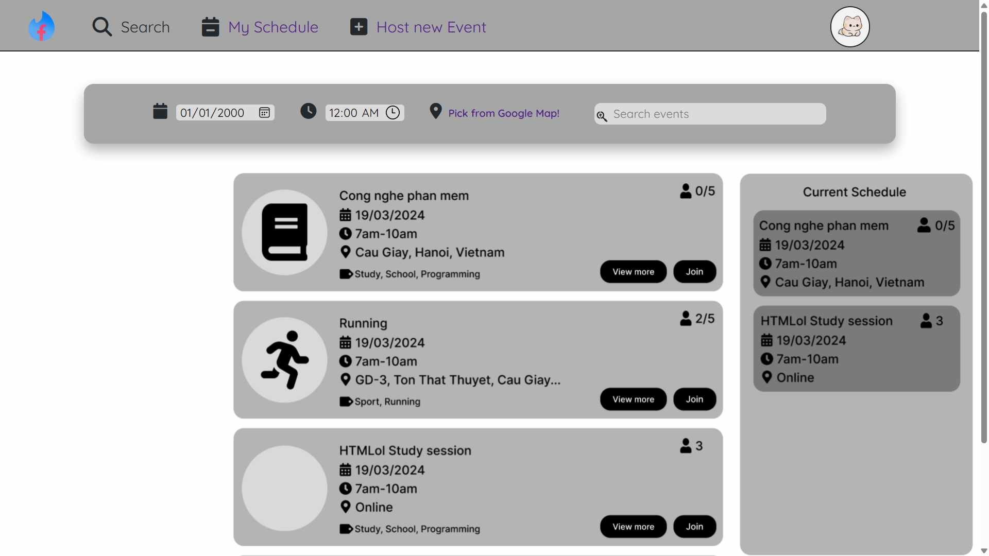

## 3.4. User profile

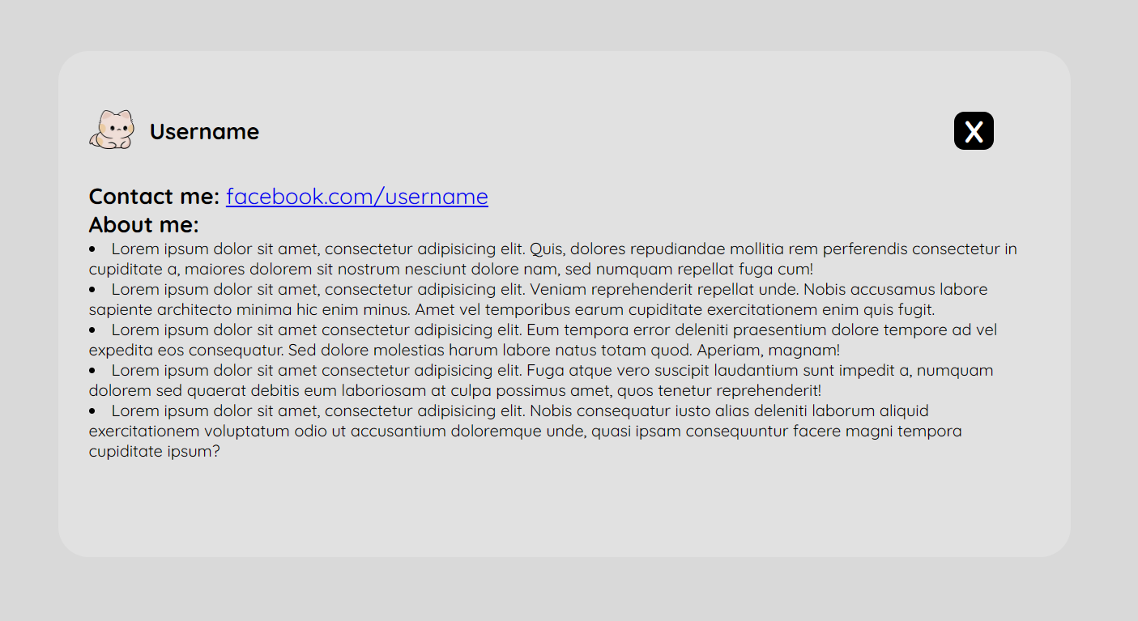

## 3.4. Edit user profile

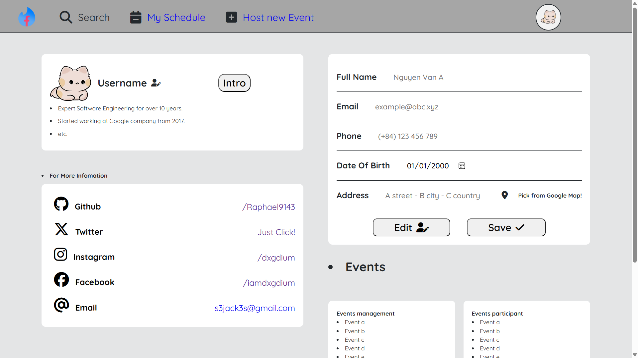

## 3.5. Host Event

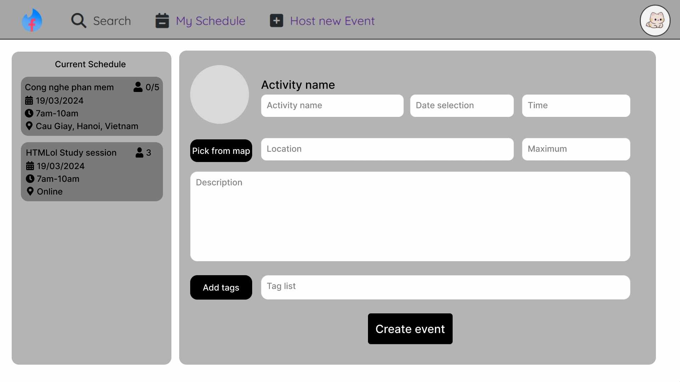

## 3.6. Event Detail

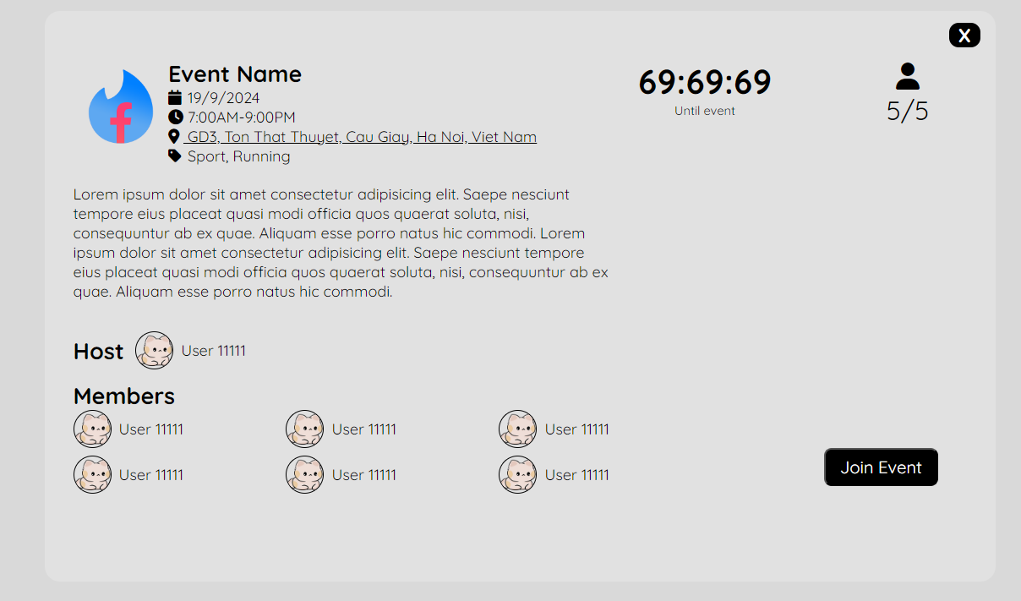

# Functional Workflow

## Login and sign up

### Main flow: login

Users enter their gmail or phone number and password to login.

### Secondary flow: forgot password, sign up, edit user profile

In the event of a forgotten password, users can simply enter their Gmail username and click on the "Forgot Password" option. Our system will then send a recovery code to their Gmail account. By entering this recovery code, users can effortlessly reset their password to a new one.

For new users, the process is equally straightforward. Simply click on "Sign Up" and proceed to fill in your name, email address or phone number for registration, set your password. Once completed, finalize the registration by clicking on the "Sign Up" button.

Upon successful registration, users will be redirected back to the login interface, where they can then proceed to log in using their newly created credentials.

After registering with basic information, users can add a profile picture, address, date of birth, gender, a self-description, etc. Additionally, they can edit their personal information as needed.

## Create new event

### Main flow: create event

Once logged in, users have the ability to create events for others to join. By clicking on "Host New Event," they are directed to a new event creation interface. Here, users can set the event name, schedule, choose a location on the map, limit the number of participants, write a description, and add tags for search optimization. Additionally, the interface displays a list of the user's joined events for reference, preventing the creation of events with overlapping schedules; the system will flag any conflicting timeframes as invalid. Finally, clicking "Create Event" finalizes the process.

### Secondary flow: modify and delete event

After creating an event, only the organizer retains the authority to edit or delete it. Event modifications are restricted to within 7 days before the start time, while deletion is limited to within 24 hours prior to the event's commencement.

## Join event

### Main flow: join an existing event

The Home interface presents users with recommended upcoming events, alongside a list of their joined events, allowing them to compare schedules and select suitable options. Should a user attempt to join an event that conflicts with one they have already committed to, the system will display a notification and prevent the action from being executed.

### Secondary flow: search event, information retrieval,user interaction, cancel a registered event

Search event: Clicking on "Search to Join" within the Home interface allows users to search for events by name and tags.

Event details: They can then click on displayed events to access detailed information, including time, location, activity description, organizer, number of participants, and the names of those attending.

User interaction: Within the "Event Details" section, users and the organizer alike can interact with each other through a comments section, similar to the engagement found in a Facebook post.

Cancel event: Users can also review a summary of their own personal information. Should they decide not to participate, they have the freedom to cancel at any time without any constraints.

# Challenges and Solutions

**Map Integration:** Integrating map APIs and ensuring efficient address-based search functionality can pose challenges. **Proposed solution:** Utilize widely-used map libraries with large user communities and extensive documentation resources to expedite problem-solving.

**Data Security:** Upon registration, users provide a significant amount of personal data, such as email addresses, phone numbers, and age, to the system. **Proposed solution:** User authentication and adherence to security regulations are crucial to prevent data leaks.

**Interface Design Issues:** The team lacks experience in designing intuitive and user-friendly interfaces. **Proposed solution:** Reference the interface designs of other systems, study materials on interface design principles, and most importantly, gather user feedback.

**Advanced Feature Development:** Implementing advanced features like personalized event recommendations, comments,.. requires complex algorithms. **Proposed solution:** The development of these functionalities will be postponed for the time being. Further research and investigation are required before they can be implemented.